**Quiz#5**

There are two programs offered by Computer Science department i.e. Graduate (MS) and Undergraduate (BS). Where Undergrad students have portfolio and Graduate students have Research profile. To graduate undergraduate students need to complete 34 hrs and graduate studenst need to complete 22 hrs courses.

Use polymorphism and concept of inheritance to solve this problem (Draw Class UML to show polymorphism and inheritance).

Interpret following into JAVA code

1.

2.

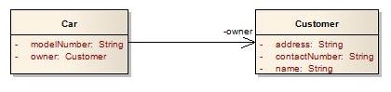

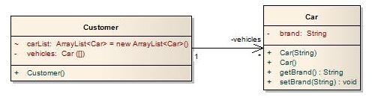3.

4.



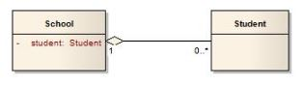5.

6.

